**Step-by-Step Guide for Deploying Kubecost on Amazon EKS with Helm for Cost Management**



**By**

**Mahendran Selvakumar**

[**https://devopstronaut.com/**](https://devopstronaut.com/)

**What is Kubecost?**

Kubecost is a tool for monitoring and managing costs in Kubernetes environments. It helps you track spending on cloud resources (like CPU, memory, and storage) used by your Kubernetes workloads. With Kubecost, you can see how much different applications, teams, or namespaces are costing, optimize resource usage, and set budgets or alerts to control spending. It’s especially useful for managing costs in cloud-based Kubernetes clusters, like those in Amazon EKS or Google GKE

**Tools Required to Deploy Kubecost on AWS EKS**

1. **eksctl**: To create and manage EKS clusters.
2. **kubectl**: To interact with and manage Kubernetes clusters.
3. **awscli**: To configure AWS credentials and interact with AWS services.
4. **Helm**: A package manager for Kubernetes that simplifies the deployment and management of applications like Kubecost

**Step 1: Create the EKS Cluster Without Any Node Groups**

Create an EKS cluster without a node group using the eksctl command **(eksctl create cluster --name=devopstronaut-cluster --region=eu-west-1 --without-nodegroup)**. By default, eksctl creates a node group with m5.large instances, so we used the --without-nodegroup option to skip creating a default node group

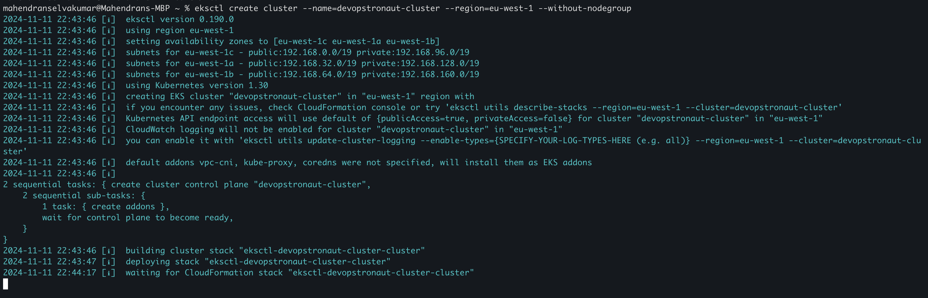

Go to the EKS console to verify that the cluster was successfully created using eksctl

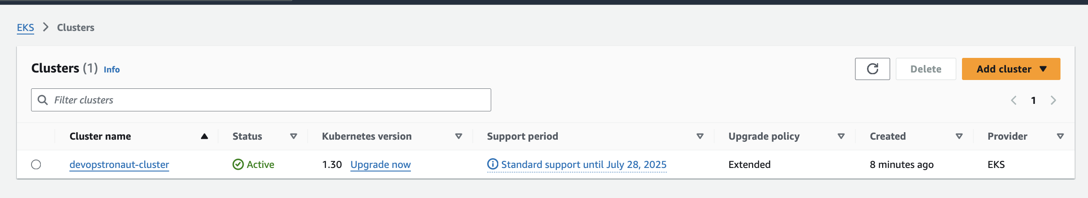

If you view the created EKS cluster in the console, you'll see that it was created without any node groups

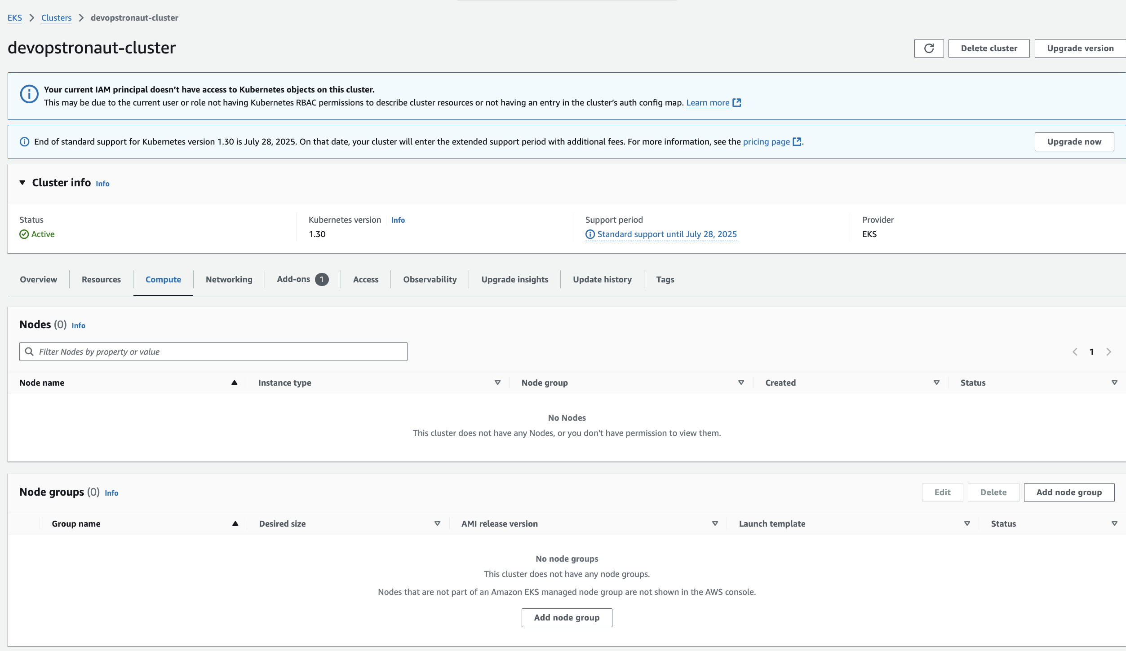

**Step 2: Create a Managed Node Group with Spot Instances**

Add a node group using the following separate eksctl command: **eksctl create nodegroup --name devops-ng --cluster devopstronaut-cluster --region eu-west-1 --nodes 2 --nodes-min 1 --nodes-max 3 --node-type t3.medium**

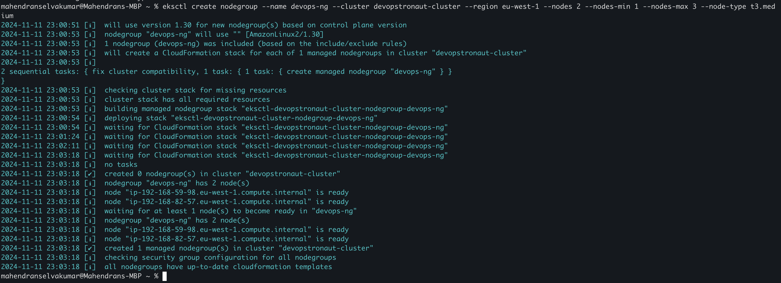

**Explanation of the flags**:

* --cluster: Specifies the name of the existing EKS cluster to which the node group will be added.
* --name: Names the node group for easy identification.
* --region: Specifies the AWS region.
* --nodes: Sets the initial desired number of nodes (in this case, 2).
* --nodes-min and --nodes-max: Define the minimum and maximum number of nodes for auto-scaling.
* --node-type: The EC2 instance type for the nodes (e.g., m5.large)

If you check in the console, you’ll see that the node group has been created

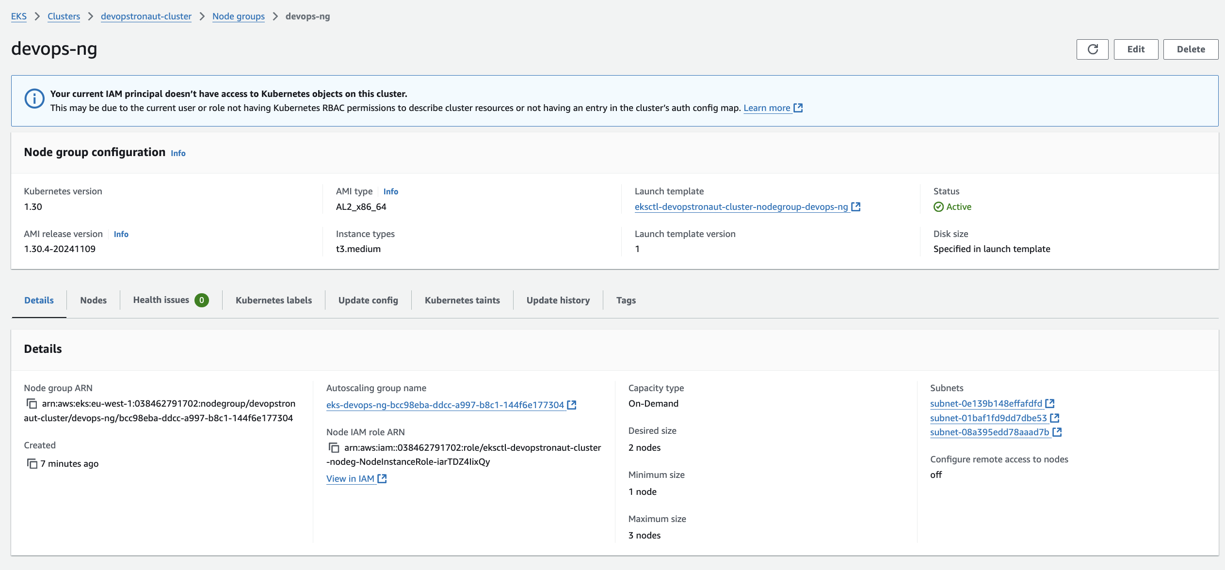

In the instances section of the EC2 console, you can view the Instances created for the node group

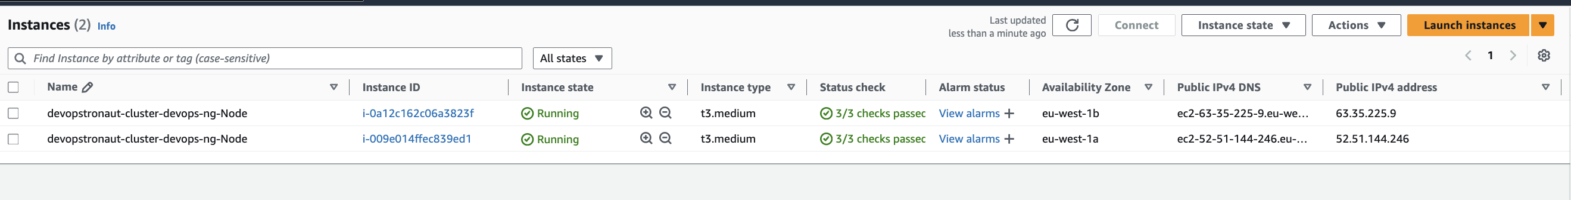

**Step 3:Configure Context for EKS Cluster:**

Set the Kubernetes context for the EKS cluster using the following command: **aws eks --region eu-west-1 update-kubeconfig --name devopstronaut-cluster**



Use **kubectl get ns** to view namespaces and **kubectl get nodes** to check the status of the nodes in the cluster, verifying that the setup is complete

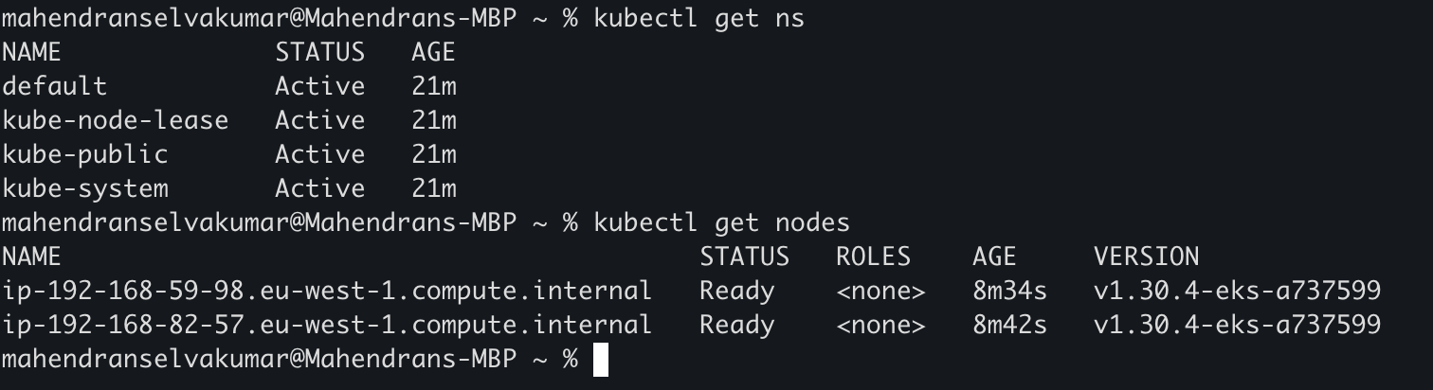

**Step4: Associate an IAM OIDC provider with your EKS cluster**

Run this command to create an OIDC identity provider for your EKS cluster **(eksctl utils associate-iam-oidc-provider --region=eu-west-1 --cluster=devopstronaut-cluster --approve)**. This step is necessary to enable IAM roles for service accounts, allowing Kubernetes workloads to securely interact with AWS services



* eksctl utils associate-iam-oidc-provider: This command creates an OIDC identity provider for your EKS cluster, which is necessary to allow Kubernetes service accounts to assume IAM roles.
* --region=eu-west-1: Specifies the AWS region of your EKS cluster.
* --cluster=devopstronaut-cluster: Specifies the name of your EKS cluster.
* --approve: Automatically approves the operation without interactive confirmation.

Once the command completes, you can verify the OIDC provider association by checking under **IAM** > **Identity Providers** in the AWS Management Console

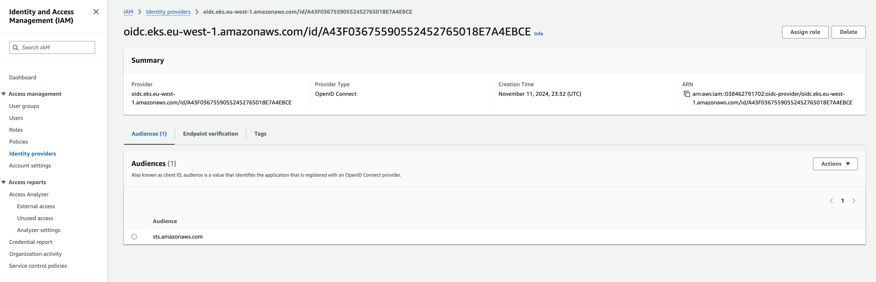

**Step5: Install AWS EBS CSI Driver**

Run the following command to create an IAM service account with the policies needed to use the Amazon EBS CSI Driver

**eksctl create iamserviceaccount --name ebs-csi-controller-sa --namespace kube-system --cluster devopstronaut-cluster --attach-policy-arn arn:aws:iam::aws:policy/service-role/AmazonEBSCSIDriverPolicy --approve --role-only --role-name AmazonEKS_EBS_CSI_DriverRole**

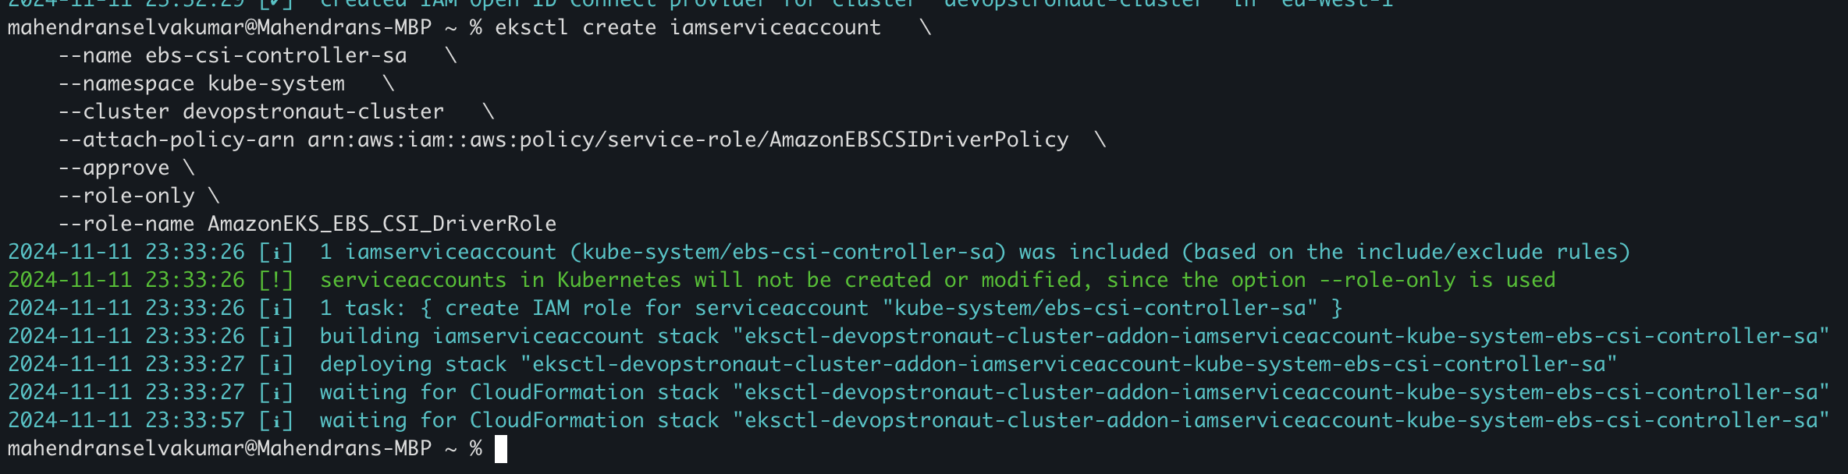

An IAM role named **AmazonEKS_EBS_CSI_DriverRole** has been created

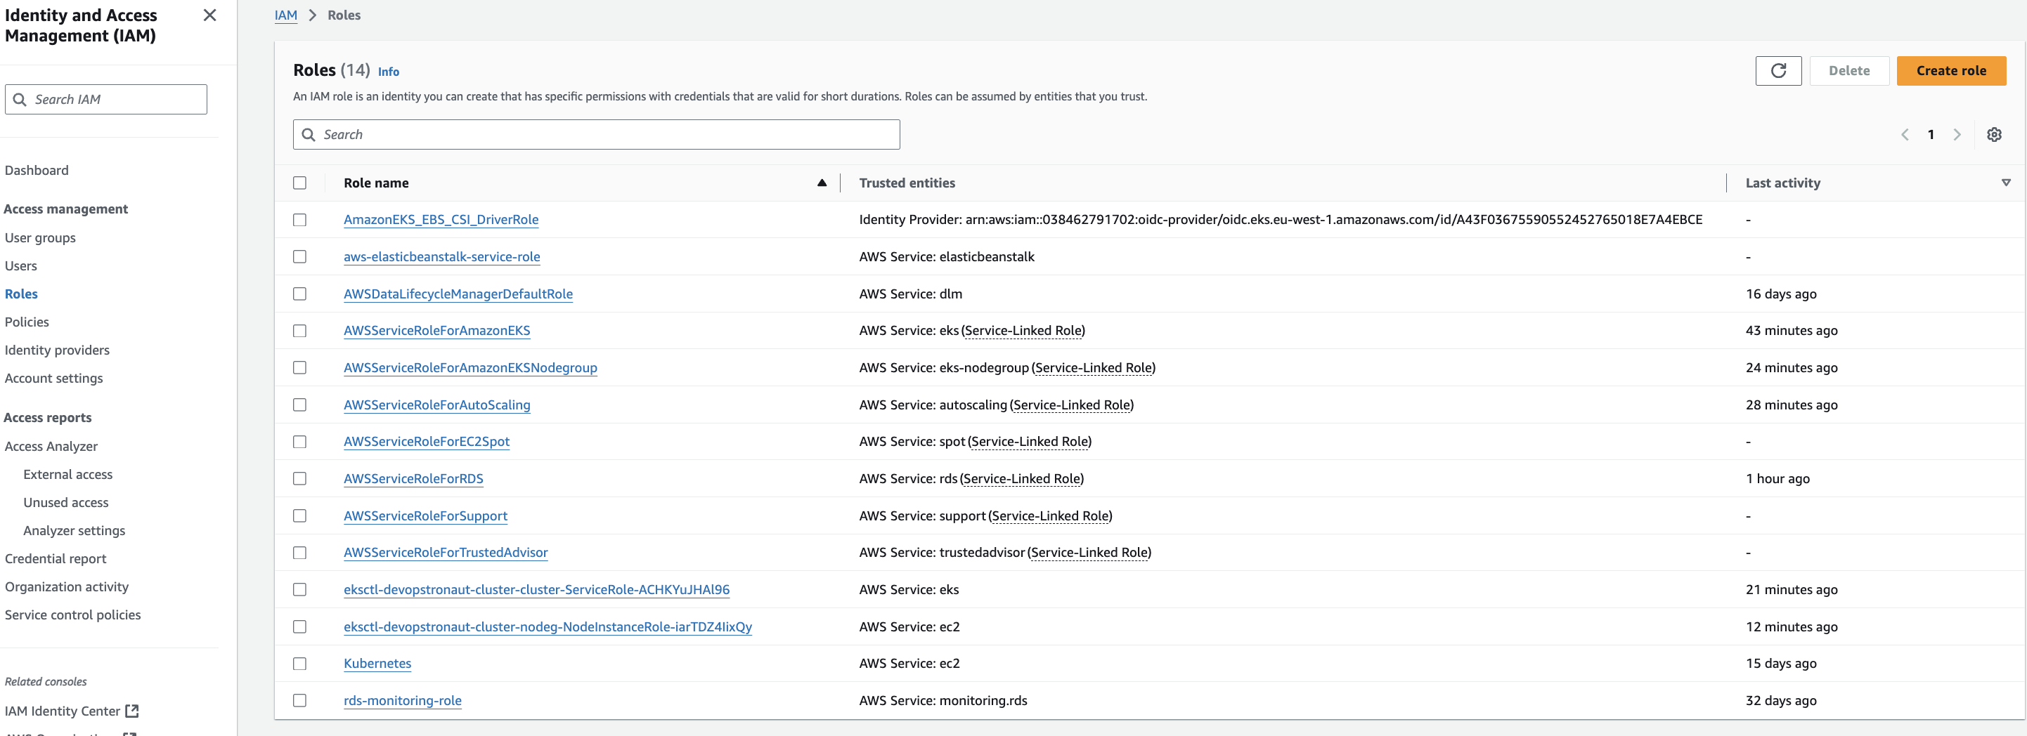

The **AmazonEBSCSIDriverPolicy** has been attached to the role

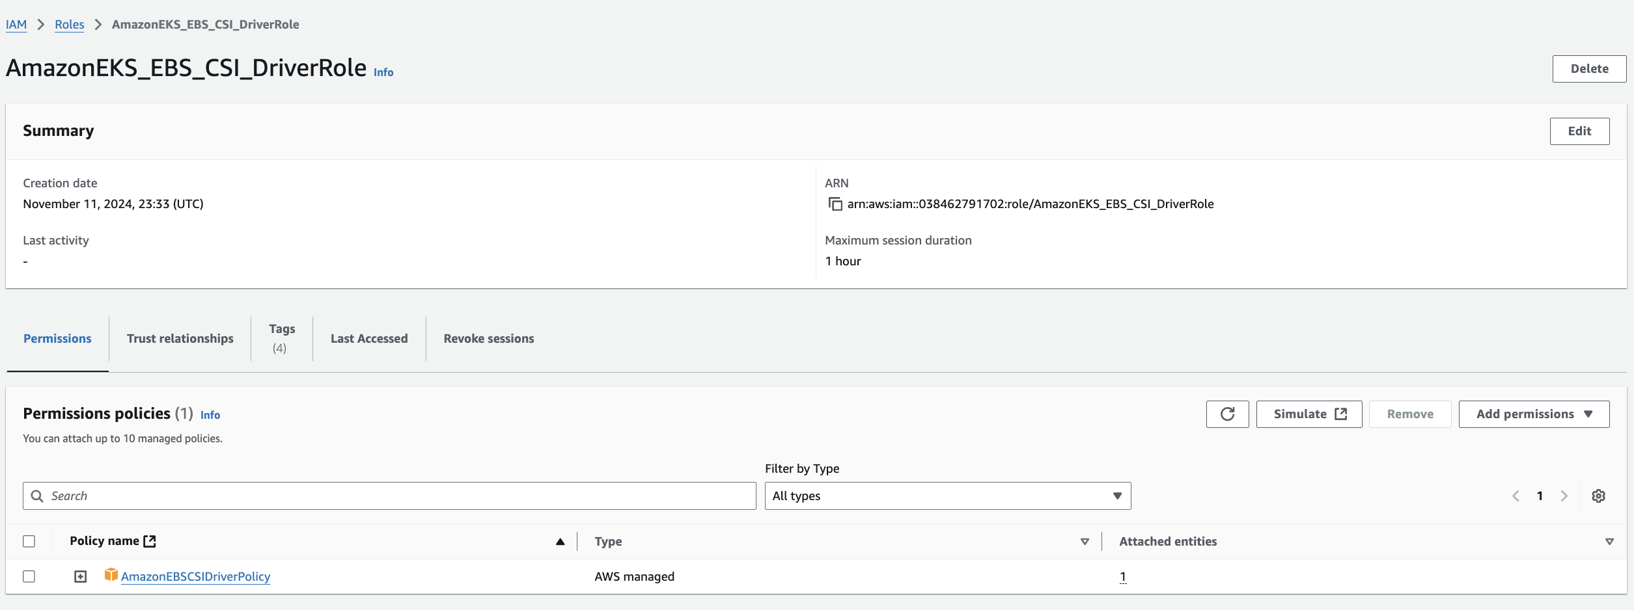

Install the Amazon EBS CSI add-on for EKS using the AmazonEKS_EBS_CSI_DriverRole by issuing **(eksctl create addon --name aws-ebs-csi-driver --cluster devopstronaut-cluster --service-account-role-arn arn:aws:iam::038462791702:role/AmazonEKS_EBS_CSI_DriverRole –force)**

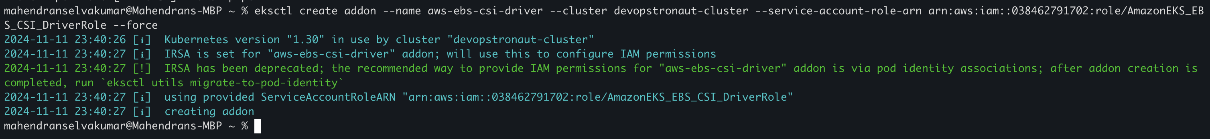

Now, check the EKS cluster add-ons to confirm that the Amazon EBS CSI Driver is installed using this command **(eksctl get addons --cluster devopstronaut-cluster)**

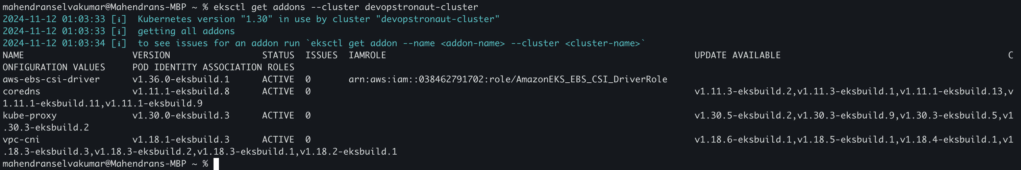

**Step6: Install Kubecost on your Amazon EKS cluster**

**Add the Kubecost Helm Repository:**

To add the Kubecost Helm chart repository to your Helm configuration, use the command **helm repo add kubecost https://kubecost.github.io/cost-analyzer/**. This integrates the Kubecost repository with your Helm setup, enabling you to install Kubecost directly through Helm



Update the Helm chart repositories using the command **helm repo update**. This command refreshes the repository information, ensuring you have the latest versions of available charts

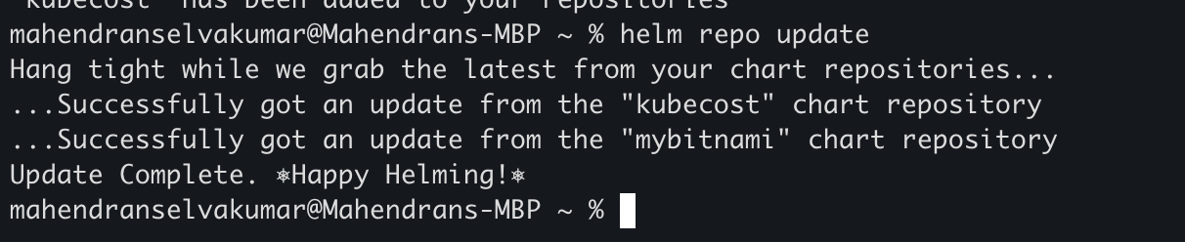

Create a namespace for Kubecost resources by running **kubectl create namespace kubecost**. This command sets up a dedicated namespace for organizing and managing Kubecost resources within your Kubernetes cluster

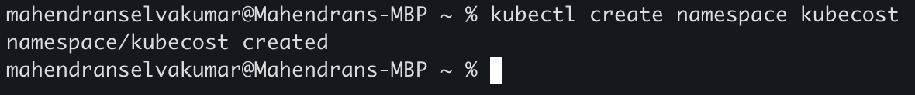

**Install Kubecost with Helm**

Run the following command to install Kubecost in your EKS cluster. You can specify a version if desired or use the latest version available:

**helm install kubecost kubecost/cost-analyzer --namespace kubecost**

This command deploys Kubecost in the specified namespace within your EKS cluster, allowing you to monitor and manage Kubernetes costs

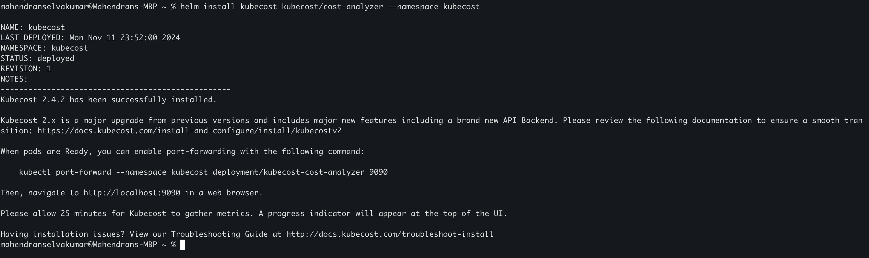

Run the command **kubectl get pods --namespace kubecost** to retrieve details of the pods in the Kubecost namespace. This will show the status and information for each pod deployed as part of the Kubecost installation

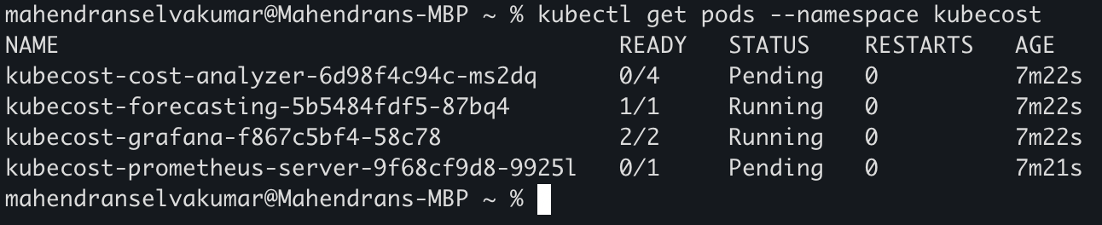

If your pods are showing a "Pending" status, use the describe command to check for details **kubectl describe pod kubecost-cost-analyzer-6d98f4c94c-ms2dq --namespace kubecost**

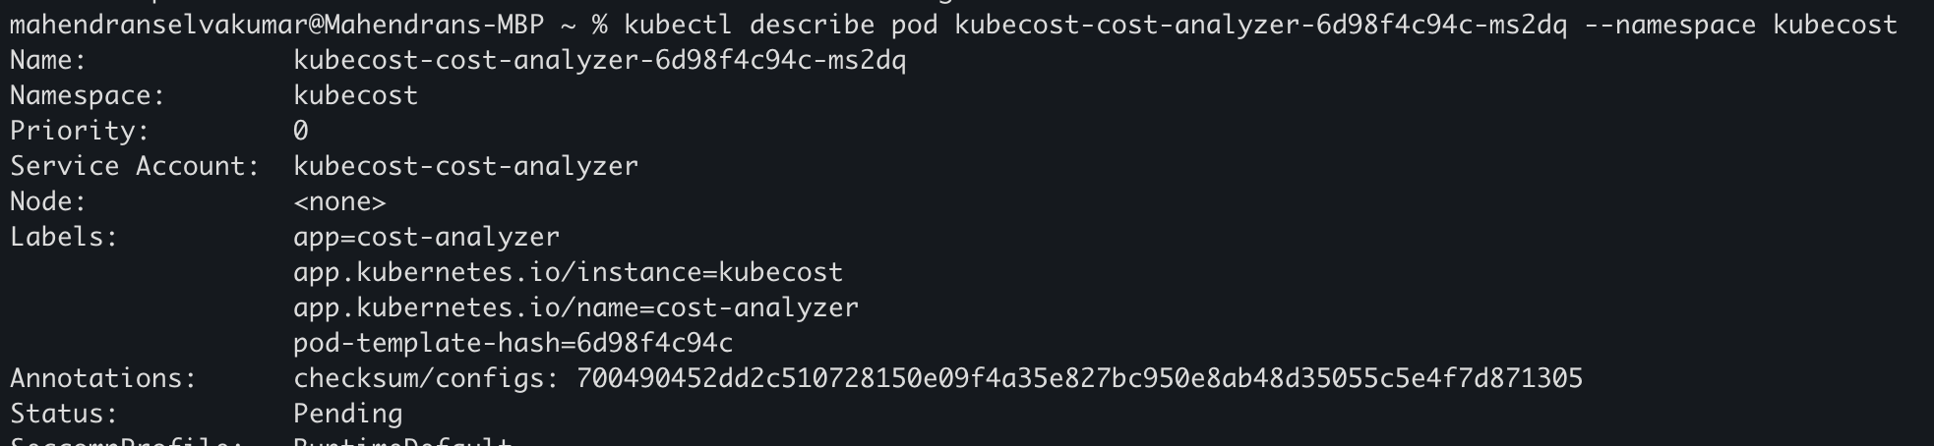

Here it shows the pod has an "unbound PersistentVolumeClaim" error

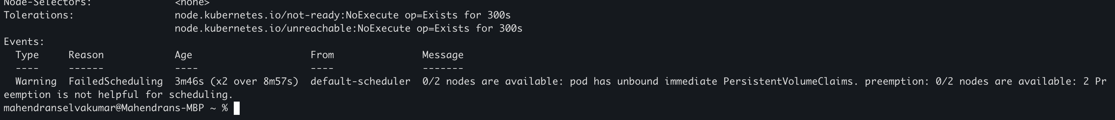

To resolve the above error, run the **kubectl get pvc --namespace kubecost** command to check the status of the PersistentVolumeClaims (PVCs). This will help identify any PVCs that are unbound and causing the issue

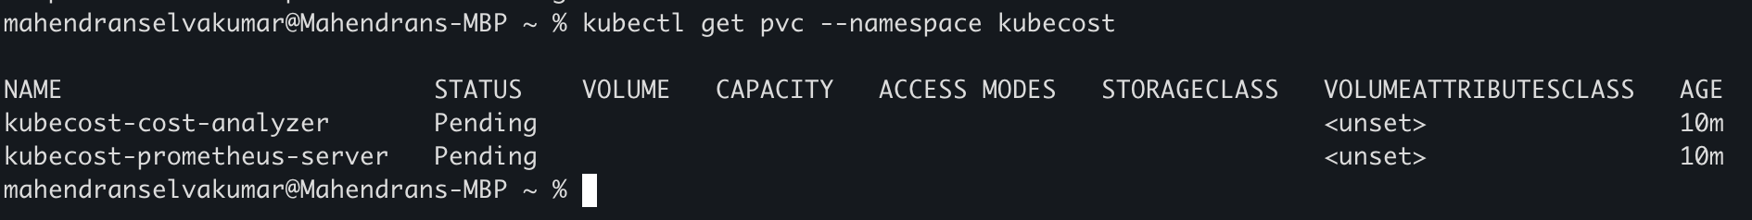

Use the command **kubectl describe pvc kubecost-cost-analyzer --namespace kubecost** to get a detailed error message for the PersistentVolumeClaim. This will provide insights into why the PVC is unbound and help you troubleshoot the issue

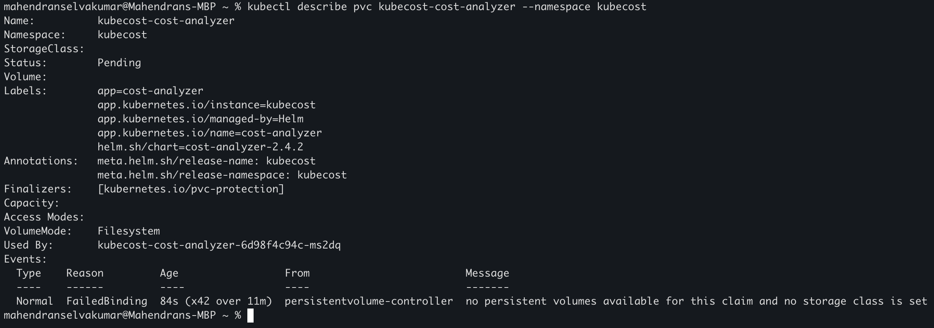

If you see the error message **"no persistent volumes available for this claim and no storage class"** it indicates that the PVC is missing a storage class. To resolve this, edit the PVC to include **storageClassName: gp2** under the spec section, **as gp2 is an AWS storage class.**

This will direct Kubernetes to use the gp2 storage class, enabling the PVC to bind to a suitable PersistentVolume

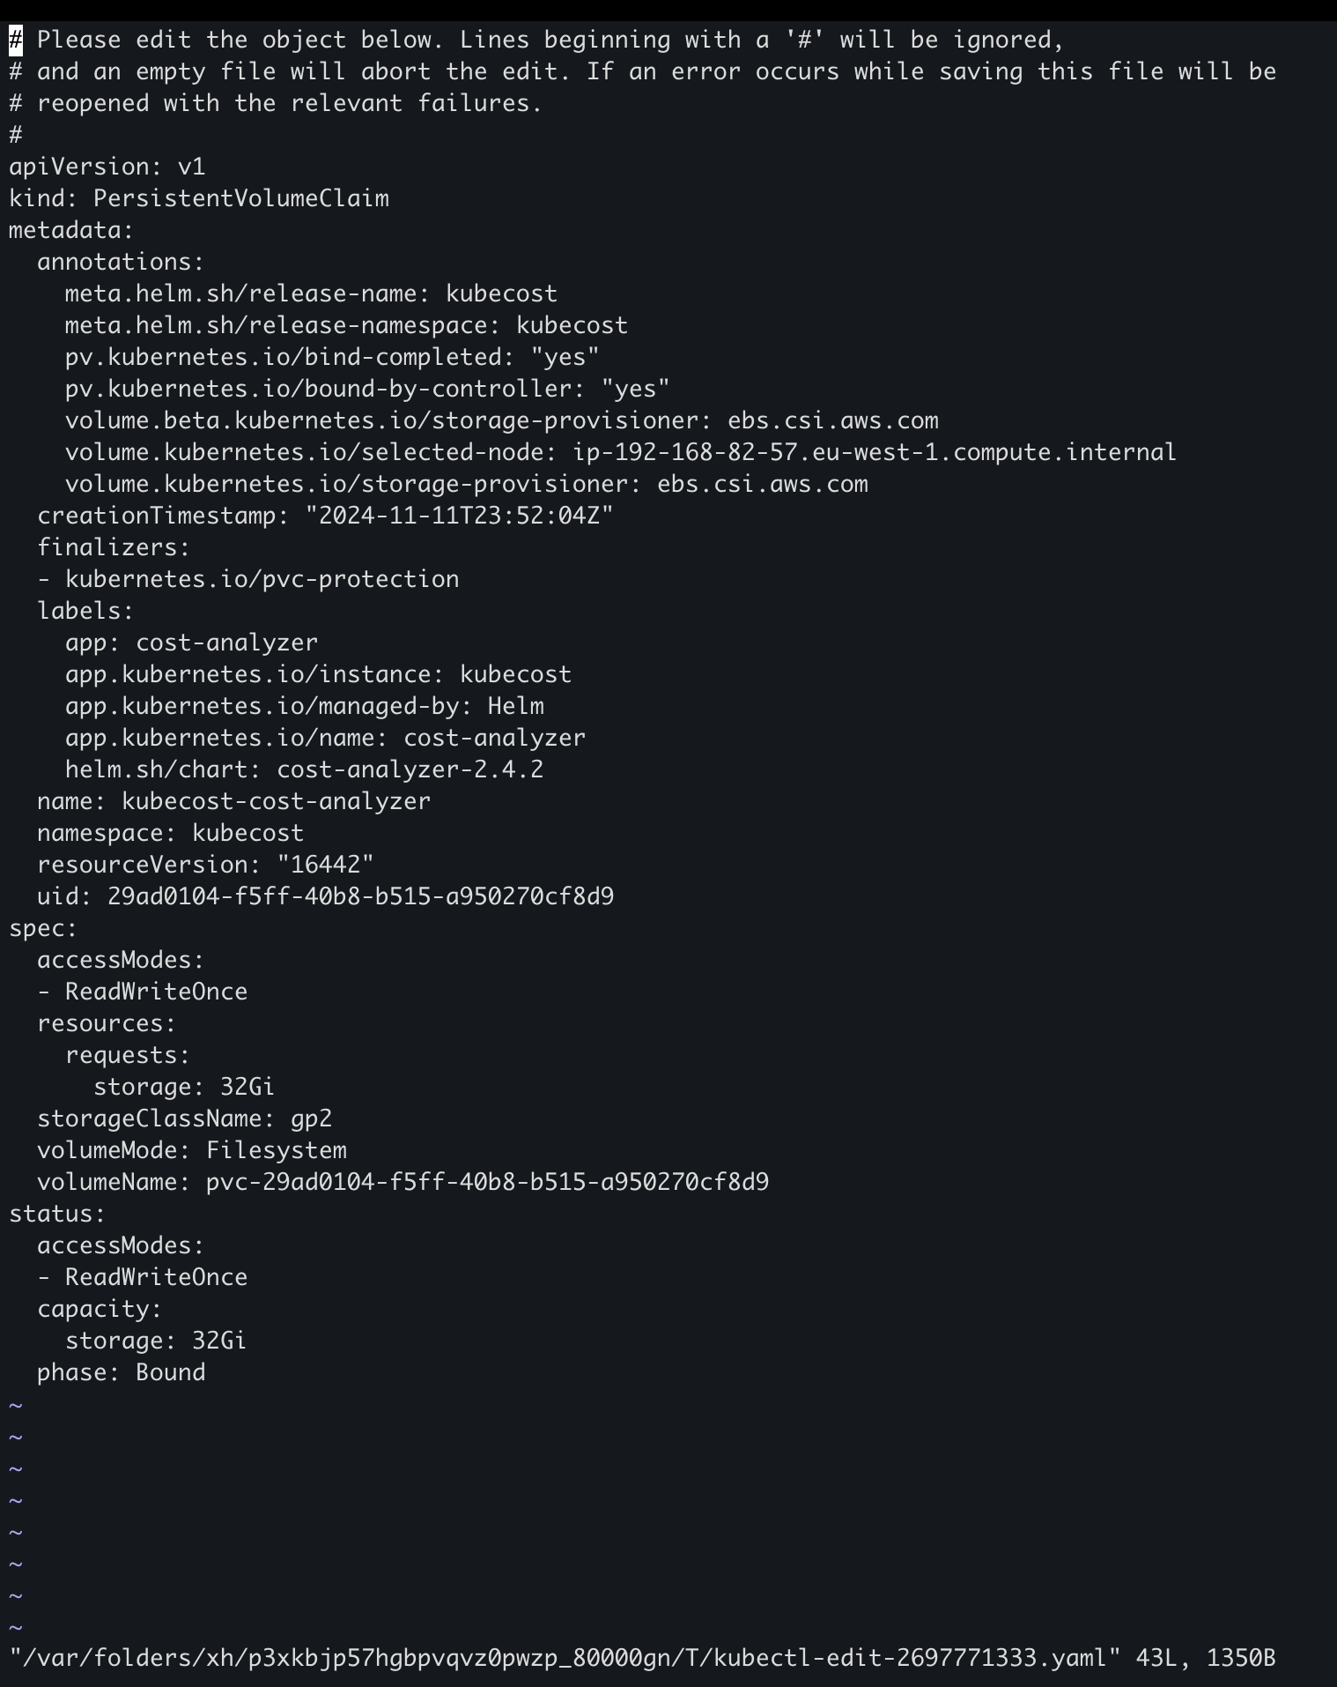

After adding **storageClassName: gp2** to the PVC configuration, save and close the file. This update will prompt Kubernetes to attempt binding the PersistentVolumeClaim to an available volume using the specified storage class



Similarly, modify the other PVC by using the command **kubectl edit pvc kubecost-prometheus-server --namespace kubecost** to add **storageClassName: gp2** under the spec section. After saving the changes, you should now see the storage class set to gp2 for this PVC as well



Now the pods should be in a running state. You can verify this by using the command:

**kubectl get pods --namespace kubecost**

This will display the status of the pods in the Kubecost namespace, confirming that they are now running successfully

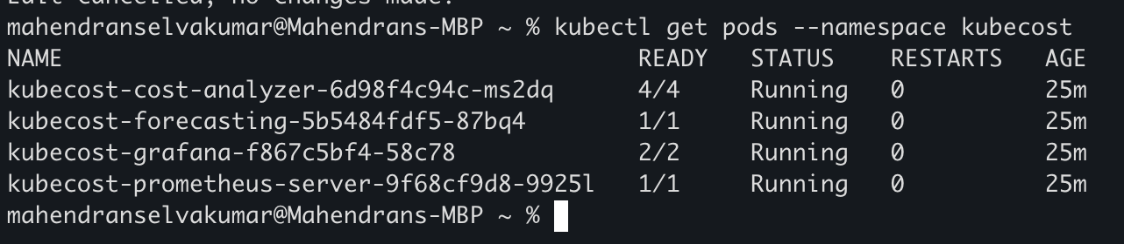

**Step7: Access the Kubecost Dashboard**

To access the Kubecost dashboard, use port-forwarding to connect to the service from your local machine.Run this command (**kubectl port-forward --namespace kubecost deployment/kubecost-cost-analyzer 9090**)



Navigate to <http://localhost:9090> in a web browser to access the Kubecost dashboard. This will allow you to monitor and manage your Kubernetes costs directly from the dashboard interface

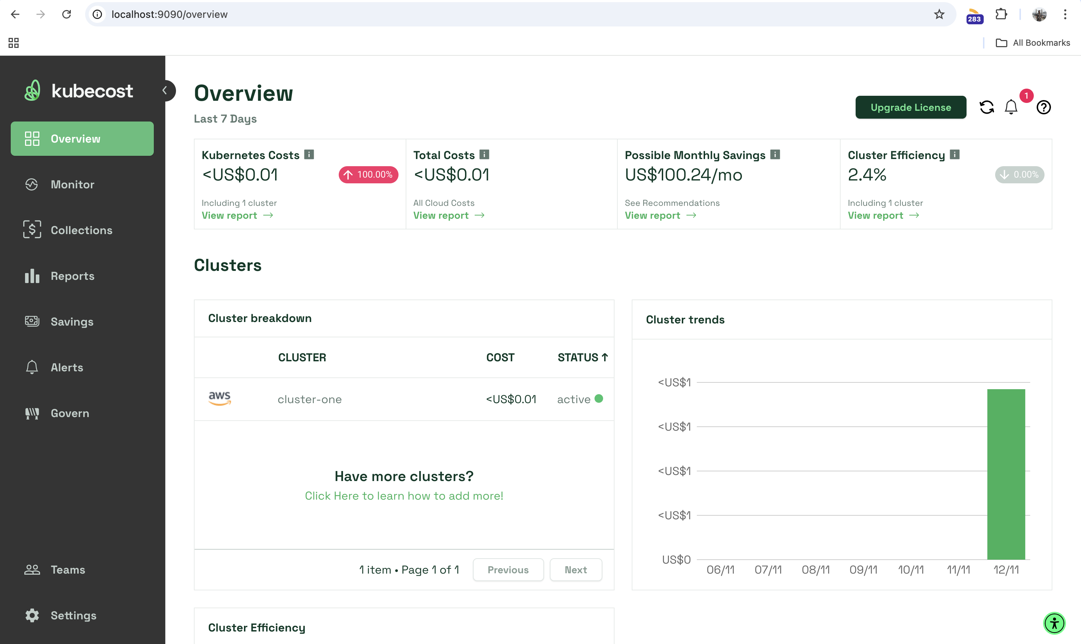

In the **Monitor** section of the Kubecost dashboard, you can view detailed information about your EKS cluster. This includes metrics on resource usage, costs, and efficiency, helping you track and manage your Kubernetes environment effectively

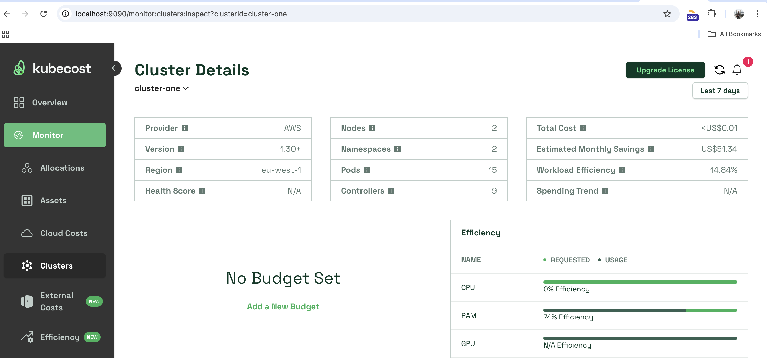

In the **Savings** section of the Kubecost dashboard, you can view monthly savings recommendations. This includes suggestions on how to optimize resources, reduce waste, and lower costs across your EKS cluster, helping you manage expenses more effectively

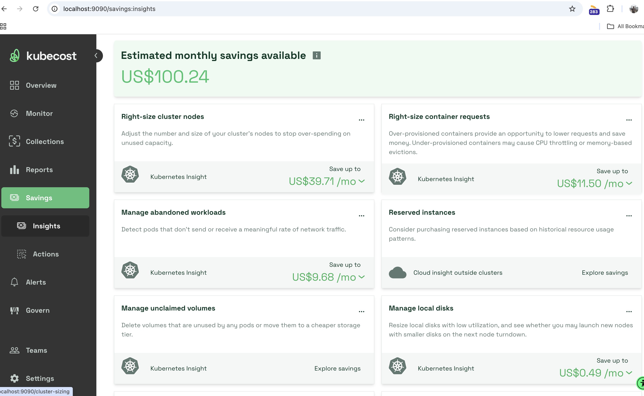

**Conclusion:**

We set up Kubecost on an Amazon EKS cluster to monitor and manage Kubernetes costs. By configuring IAM roles, storage settings, and accessing the Kubecost dashboard, we gained visibility into resource usage, cost allocation, and savings opportunities. This setup helps teams optimize cloud expenses and manage Kubernetes resources efficiently

Keep Learning, Keep EKS-ing!!

Feel free to reach out to me, if you have any other queries or suggestions Stay connected on LinkedIn: [Mahendran Selvakumar](https://www.linkedin.com/in/mahendran-selvakumar-36444a77/)

Stay connected on Medium: <https://devopstronaut.com/>